IRWRMC Proceedings manuscript

Name Surname *a, Name Surnameb,

aDepartment…, University/Compagny …, City, Country

bDepartment…, University/Compagny …, City, Country

Abstract

Begin the abstract two lines below the affiliations. The length of the abstract is approximately 100 words.

**Keywords:** Select up to 5 keywords, separated by comma

# INTRODUCTION

Begin the Introduction two lines below the Keywords. The manuscript should not have headers, footers, or page numbers. It should be in a one-column format. References are noted in the text1 by numerical superscript according to their appearance order and cited at the end of the paper. The maximum length of the whole paper is **5 pages for normal papers** (please note that the minimum length of the whole paper is 4 pages).

## Margins

Please use the margins of Table 1 (same with this document).

Table 1. Margins and print area specifications.

**PAPER MARGINS**

A4

Top margin 2.5 cm

Bottom margin 3.5 cm

Left, right margin 1.9 cm

## Fonts

Table 2 shows the font sizes and highlighting in a typical manuscript. These font "styles" are contained with this sample manuscript and Section 4 below explains how to use them. Use Times New Roman to avoid font errors.

*aaabbbccc@univ-artois.fr; phone 0033 1234 5678  
Table 2. Manuscript font sizes and formatting.

## Paper title 16 pt. bold, center

## Authors/affiliations 12 pt., center

**Keywords:** *Keywords* 10 pt., left justify

### ABSTRACT TITLE 11 pt. BOLD, center

abstract body text 10 pt., justify

### SECTION HEADING 11 pt. BOLD, center, whole numbers

**Subsection heading 10 pt. bold, left justify, subsection numbers**

body text 10 pt., justify

figure caption 9 pt., below figure, centered or indented

table caption 9 pt., center above figure

footnote text 9 pt., justify, numbered

**REFERENCE HEADING 11 pt. BOLD, center**

Reference listing 10 pt., justify, numbered in brackets

# Formatting of manuscript components

## Title

Center the paper title at the top of the page in 16-pt. bold. Only the first word, proper nouns, and acronyms are capitalized. Keep titles brief and descriptive. Spell out acronyms unless they are widely known. Avoid starting with articles or prepositions, e.g., “The study of … ,” or, “On the ….”

## Author affiliations

The author list is in 12-pt. regular, centered. The list of affiliations follows. Each author's affiliation should be clearly noted by a superscript.

## Section headings

Section headings are 11-pt. bold capitals, centered. Sections numbers have whole numbers, e.g., 1, 2, 3… Do not number the "Acknowledgements" and "References."

## Subsection heading

Subsection headings are left-justified, 10-pt. bold. Capitalize the first word, acronyms, and proper nouns.

## Paragraphs

Add a blank line above and below section headings and between paragraphs.

## Text

Text is 10 point and fully justified. Each sentence ends with a period and a single space before the next sentence.

## Tables and figures

Tables are centered. The caption goes **above** the table. The caption text should indent 5 spaces from left margin and justify. Table examples are on page 1 and 2 and below.

Figures are centered. The caption goes **below** the figure. The caption text should indent 5 spaces from left margin and justify. A table and figure example is shown below.

Table 1. Experimental design

|  |  |  |  |  |  |
| --- | --- | --- | --- | --- | --- |
| **Mix** | **Temperature** | | **VMA dosage** | | ***HRWRA demand\****  ***(% cement mass)*** |
| Coded  value | Absolute  (°C) | Coded  value | Absolute  (% water mass) |
| Ab1 | -1 | 13 | 1 | 0.87 | 1.5 |
| Bc2 | 1 | 29 | 1 | 0.87 | 1.2 |
| Cd3 | Central points for experimental error (Average of 4 replicate points) | | | | |
| 0 | 21 | 0 | 0.48 | 1.0 |

* To keep the SCC slump flow at 650 ± 10 mm (10 minutes after the contact cement-water)

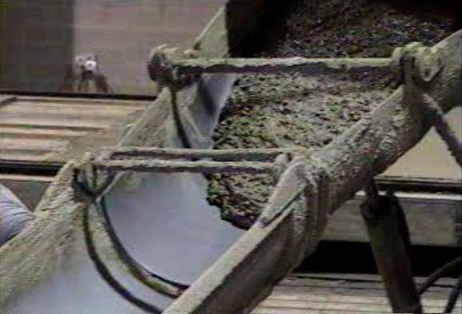

Figure . Figure captions are centered as well as the figures.



Figure 2. Variation of integrated area with the dosage of VMA at 11.3, 21 and 30.7°C

# Mathematical Equations

Use common fonts like Times Roman. The different equations are numbered using a number in parenthesis at the right of the line, for example

 (1)

# CONCLUSIONs

Conclusions should state concisely the most important findings reported in the paper, as well as the author’s views of the practical implications of the results.

References

1. Wallevik OH (2003) Rheology—a scientific approach to develop self-compacting concrete. In: Proceedings of 3rd International RILEM symposium self-compacting concrete. Reykjavik, pp 23–31
2. Yahia A, Khayat KH (2003) Applicability of rheological models to high-performance grouts containing supplementary cementitious materials and viscosity enhancing admixture. Mat and Struct 36(6):402-412
3. Ramge P, Proske T, Kuhne H-C (2010) Segregation of coarse aggregates in self-compacting concrete. In: Khayat KH, Feys D (eds) Design, production and placement of self-consolidating concrete. Springer, Dordrecht, pp 113–125